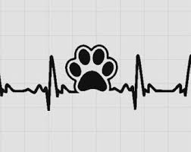
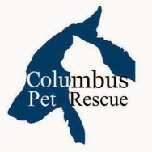
2016 in Review

ADOPTAPALOOSA 2016
• • •
A huge thank you to all the volunteers and participants who helped make our first “Adoptapaloosa” a great 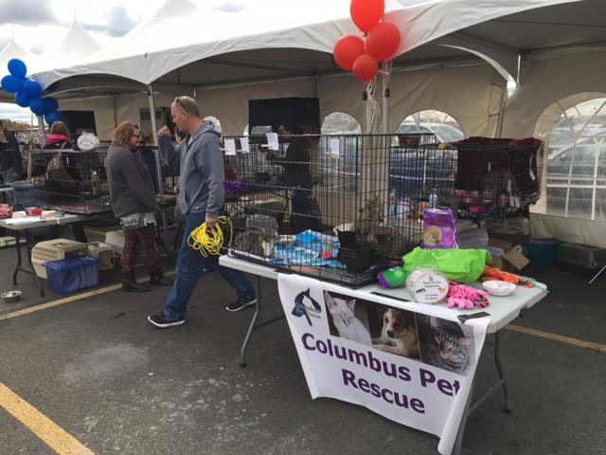success. Over 70 animals were adopted out by Columbus Pet Rescue, Colony Cats, DASH, Team Greyhound, and the Capital Area Humane Society. We are considering doing this again in the fall. Hopefully, this next time the weather will 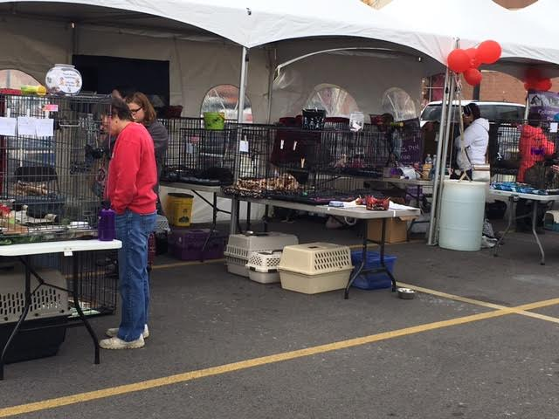cooperate a little more and it won’t be so cold, the Columbus firetruck will not be called to a fire, and the Police K-9 unit will be able to visit as well.
CPR Heartbeat
Columbus Pet Rscue | 4/17/2017 | Edition 4.17.17

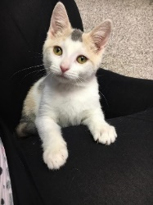
  - It was a good year…

It has been quite a year for Columbus Pet Rescue. We have adopted close to 300 cats and dogs to loving homes and helped over 250 animals needing neutered/spayed or other medical care. In addition, CPR continues to feed and care for several feral cat colonies throughout central Ohio. We would like to do so much more, but are limited by finances and foster availability. Have you thought about opening your home to a
Please consider a one-time donation of $50 or $100, or better still, commit to a $20 or $30 monthly donation. We would be happy to send you an ETF form. You may also go to our website at www.ColumbusPetRescue.com , click on Donate and “Ways to Give.” PayPal, AmazonSmile, Kroger, Couture for a Cause, a check, or Petsmart Gift card are just a few of the methods you can use to help.
pet in need? We provide the food, litter, supplies, veterinary care; you supply the love. If you can’t open your home for a pet in need, can you open your wallet? Our adoption fees do not cover the expenses we have vaccinating, FeLV/FIV and heartworm testing, worming, flea treating, spaying or neutering, feeding, and caring for these animals. We need generous donors to help us continue to be able to help them. All donations are tax deductible.

Rufus is grateful!!

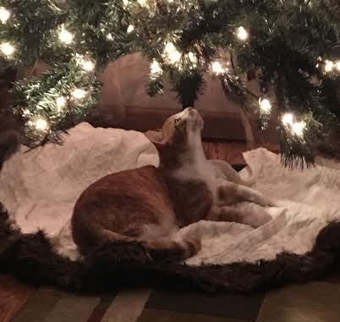
THANK YOU to all who contributed to Rufus’s GoFundMe page. His surgery was a success. He was adopted to a great home in time for Christmas and is livin’ it up without constant eye pain.

Reasons You Can Foster a Cat — Even If You Think You Can’t
This article was originally published on the Petfinder blog. By Emily Fromm
“I DON’T HAVE THE SPACE” — I used to think this too. Then a cat came along that really, really needed me … and I made the space! All it takes is a small spare bedroom or office, a bathroom, or even a corner where you can set up a playpen cage, which you can borrow from CPR! While we do need foster cats to stay separate from your own cats, it doesn’t take much space to do that. Remember, whatever space you have at home is probably safer and better than the kitty has in its current situation!
“I MIGHT GET ATTACHED” — OK, yes, you might. But no matter how difficult it is to give your kitty over to its new home, just knowing that you’re helping to save a life should ease any short-term pain. When you take in a foster cat, it gives us room to help other cats that might otherwise be brought to shelters that euthanize for time and space. It also lets us learn more about a cat’s personality which, in turn, makes the cat much easier to adopt out. Yes, some cats are harder to bring back than others, but be strong! You can do it! (And yes, I’ve kept one foster cat, but not the 60 that followed that first one!)
“MY OWN CATS WON’T TOLERATE A FOSTER CAT, ESPECIALLY AN ADULT” — If you have a separate room, this shouldn’t be much of a problem. Yes, your cat(s) will know there is another cat in the house, and they may be a little upset about it at first. But chances are they’ll get over it pretty quickly, especially if you make sure you wash your hands after visiting with the foster cat and keep the cats from seeing each other if possible. Tell your cats they need to help do their part too! Eventually, they will be totally nonchalant about the whole idea of fostering. My cats no longer even bat an eyelash when a foster cat comes into the house.
“I CAN’T AFFORD TO TAKE ANOTHER CAT” — This one is easy! You can get all your food and litter from CPR, if you like, and CPR covers all medical expenses associated with foster cats! If you buy your own supplies for fosters, save the receipts so you can take a tax deduction!
“SOMEONE ELSE WILL SAY YES. THERE ARE PLENTY OF OTHER FOSTER HOMES” — They won’t and there aren’t. It’s that simple. We have lots of folks who will take kittens, but very few who will take adults, and even fewer who will take sick, feral, and/or rabies-quarantine cats. Please help us! Kittens are easy for us to place. But our poor adults need help too.

Go online and fill out a foster application today!!

April

is
"Prevent Cruelty to Animals" month!
Be our eyes and ears! Notify CPR or the Capital Area Humane Society if you see animal cruelty or abuse.
Signs of potential animal abuse include animals that:
- Have sores, look sick or injured, or are obviously underweight.
- Are kept without access to adequate shelter, food, and water.
- Appear abandoned.
- Are in unsanitary or overcrowded conditions.

